International Journal of Disaster Risk Reduction
Evaluation of the emerging opportunities for improving risk awareness and resilience of vulnerable people in disasters
Juhani Latvakoskiª, Risto Öörni, Toni Lusikka, Jaana Keränen
ª*, VTT Techical Research Centre of Finland, Kaitoväylä 1, FI-90571, Oulu,Finland

Abstract
The main contribution of this research is the evaluation of emerging technological opportunities for improving risk awareness and resilience of vulnerable people in disasters. The evaluation was carried out in three phases: a survey of existing emerging technologies and tools, end user evaluation of specific tools in use cases and evaluation in four co-creative international workshops. Evaluations targeted to evaluate the critical issues related to the innovation potential of selected emerging technologies from such perspectives as desirability and usefulness of the new emerging technology, level of use, importance, applicability, capabilities in pinpointing vulnerable people, risks and challenges, gaps and ethical acceptability.
The end user evaluations of specific tools were conducted in three use cases: mobile positioning data (MPD) tool with two different dashboards as example tools applying location based services for increasing risk awareness, and Trasim tool as an example tool applying simulation technologies to crisis communications training. An MPD tool dashboard was applied in the use case applying mobile positioning data for more precise rescue planning and emergency management under cyber-hazard in Estonia. The evaluation shows the most respondents considered the ethical risks to be very unlikely or unlikely to be realized. The other MPD tool dashboard use mobile operators’ data to locate, protect, and evacuate tourists and other vulnerable groups in disasters in Indonesian use case. Results indicate the majority of the respondents classified more ethical risks at least likely to be realized. It is expected that is because of differences in the MPD tool dashboards and differences between countries in perception of risks related to processing of personal data. The Trasim tool was applied in managing a chemical spill emergency and mis/disinformation through simulated responses use case in Finland. In the end user evaluation of it, the respondents were willing to use the tool themselves again and mostly considered the tool achieving its purpose, but slightly less agreed with statements on Trasim’s suitability for civil protection, crisis management or disaster risk reduction. The reason for this may be caused by relatively specialised scope of the Trasim tool and uncertainty on whether training sessions where Trasim is applicable should be regular activities or organized as one-off training events.
The evaluation in co-creative workshop targeted to evaluate technologies in following themes: (satellite-based solutions, 5G, Internet of things, drones, artificial intelligence), location-based services, data sharing between authorities, and crowdsourcing for improving preparedness. of the emerging technologies in collaborative workshops rise substantial differences related to ethical issues. The satellite-based solutions appeared to have the fewest ethical issues, while location-based solutions and artificial intelligence thought to have the most ethical issues but they were estimated not to have major ethical issues. Drones, location-based services, satellite-based solutions, and crowdsourcing were assessed to have great innovation potential. Crowdsourcing and artificial intelligence were estimated to be able to increase or create risks for vulnerable people more than other technologies involved in the evaluation. Drones, location-based services and crowdsourcing were estimated to have great benefits with regard to their costs. The most important technologies to be adopted for regular use were estimated to be drones, location-based services, and data sharing between authorities.
The satellite-based solutions and drones could offer new ways to identify vulnerabilities in environmental disasters. The resulting information, satellite pictures, visual information from drones (e.g. infra-red etc.) could be applied to identify the problems, find evacuation routes and people needing help etc. The challenges are risk of misuse, high operational cost, low frequency and slow image data processing, illegal detection of private spaces, risks for spying people and even terrorism. Location based solutions can be used to locate vulnerable people, identify them and their vulnerabilities, and used to contact them in the disaster area. The challenges are potential misuse of privacy sensitive data, ethical issues, risk that such personal data is applied for commercial purposes without permissions, and even illegal purposes by criminals. Artificial intelligence could help rescue organization to detect urgent help requests from social media platforms, and it could also be used to identify abnormal events and weak signals of undesirable phenomena from social media channels, that may indicate gradually evolving patterns. The challenges are related to potential raise ethical and privacy issues, and thus risk for such information misuse. Crowdsourcing can reveal new vulnerabilities for crisis management or care-providing organizations related to the realities and viewpoints of people so that the people themselves reveals their or neighboring people conditions. The challenges arise from excluding some vulnerable groups of people living without smart phones and capabilities to use social media tools, and the wrong or misleading information which may have hostile intentions.
Summarizing the results from co-creative workshops, data security, data sharing, personal data protection, violation of privacy and potential misuse of data was seen as a considerable concern in most of the analysed emerging technological opportunities. There is already a lot of data and information available, but the challenge arises from the barriers between different actors to share and use of the information. Sharing the information may be limited even by law so that the official responders cannot share information with non-governmental organizations (NGOs). Combining data from different sources can improve the situation awareness of authorities in crisis, however, the challenge is arising from the heterogeneity, interoperability, governance and access towards such information. The governance of the data according to the needs of the owners as well as data protection, privacy and security need to be seriously considered when storing and sharing the data for other stakeholders. Ethical aspects should also be taken into consideration when planning of data gathering, sharing and usage as breaches in data protection could potentially make people (more) vulnerable.
The digital divide between people related to unequal distribution of skills, access to technological means and tools stays to be an essential future challenge, especially with vulnerable people in a crisis. Older people, children, homeless people, and people with limited economical resources can be considered vulnerable people. There are people that have a higher (or very high) risk of becoming vulnerable in crisis due to inequalities, not being considered or supported etc. Issues of fairness and inclusivity need great attention in the application of these technologies in crises or disasters in order not to oversee such vulnerable people. It is very essential that these issues are considered and included in the monitoring radar of the emergency planners and responders. Furthermore, the cease of vital infrastructures, such as electricity cutoff or the damage of communication infrastructures, indicates the fragility of the technological tools in a hazard situation. The failure of the tools may retain dependent services and service users in risk or exacerbate the existing vulnerabilities, and the functionality of the surrounding technological structures have an impact on vulnerability in crisis. However, the potential of the discussed technical opportunities for improving operation in different disaster life-cycle phases is so essential that significant investment on research and development actions is recommended.

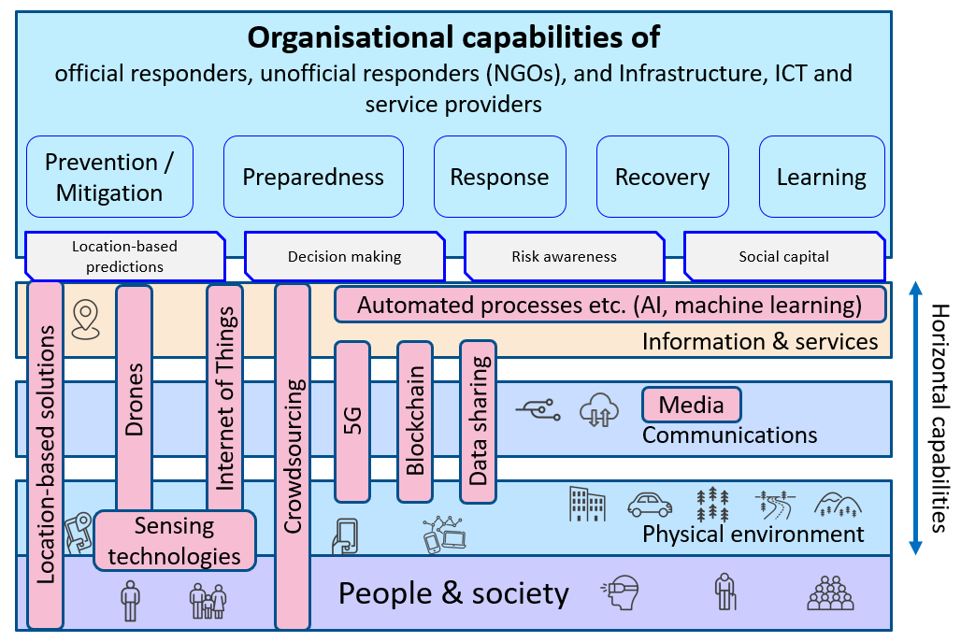
Figure 1. Emerging technologies enable new ways to collect data in disaster situations. Modified from D1.2 & D2.4 & Latvakoski, J.; Alaya, M.B.; Ganem, H.; Jubeh, B.; Iivari, A.; Leguay, J.; Bosch, J.M.; Granqvist, N. 2014. Towards Horizontal Architecture for Autonomic M2M Service Networks. Future Internet 2014, 6, 261-301.

© 2022

March 2022)

* Corresponding author. Tel.: +358 40 5200149; fax: . E-mail address: Juhani.Latvakoski@vtt.fi

